**AP CSP CodeX**

|  |  |  |
| --- | --- | --- |
| **MISSION 5 Micro Musician** | | **Time: 45 minutes** |
| **Project Goal:** Students will turn on and off the four RGB LEDs (NeoPixels) on the CodeX.  **Learning Targets**   * I can make the CodeX play music through the speaker or headphone. * I can add blank lines and comments to my code to increase the readability. | **Key Concepts**   * Program readability is important and can be accomplished by using blank lines and adding comments to the code. * Batteries in the CodeX can make your code portable. | |
| **Assessment Opportunities**   * Mission 5 Assignment * Quiz after Objective 5 * [Mission 5 Kahoot Review](https://create.kahoot.it/share/firia-labs-ap-csp-mission-5/534e2027-355c-432d-bd71-c29384bd326c) * Music1 program | **Success Criteria**   * Create a program that plays an audio file * Add readability to the code by adding blank lines and comments | |
| **AP CSP Framework**  **CRD-2.G** Describe the purpose of a code segment or program by writing documentation.  **Computational Thinking Practice 5.A** Explain how computing systems work. | **Materials**   * Mission 5 Assignment / Answers * [Mission 5 Kahoot Review](https://create.kahoot.it/share/firia-labs-ap-csp-mission-5/534e2027-355c-432d-bd71-c29384bd326c) * AP CSP CodeX Vocabulary List * AP CSP CodeX Python Code List * Unit 1 Review Links and Test Questions | |
| **Teacher Notes**   * Start the lesson by going over the CodeX Mission Reminders slides. * At the end of the lesson, discuss clearing the CodeX before turning it in. You can use the Clearing CodeX slides. * The assignment is best completed digitally. Prepare the assignment for distributing through your LMS. * **Something to watch for!** Objective 4 has names of MP3 files loaded onto CodeX. In order to play the files, the folder they are in must be included. Students always need to use **(“sounds/filename”)** in their code. * **Something to watch for!** Students can use double quotes (“ “) or single quotes (‘ ‘). Either one works. * Students are asked to include a multiline comment to the top of their code in Objective 5. * The Mission 5 Kahoot Review covers concepts and vocabulary from the earlier missions as well. * Another suggestion for assessment is for students to keep a daily journal, or use a reflection form for students to process information they learned and reflect on questions they may still have. * You may consider having students (or the class collectively) keep a chart of errors and the ways to fix them. * You can also add vocabulary to a word wall and keep a document or chart of the Python code learned during each mission. * Refer to the Python with CodeX Curriculum Guide or Mission 5 Lesson Prep (found in the l[earning portal](https://learn.firialabs.com/curricula/python-with-codex/teachers-resources/codex-teacher-materials)) for more information. * The teaching guide (below) gives the narration for one way to present the lesson. | | |

**Teaching Guide**

**Warm-up (5 - 15 minutes)**

The actual coding part of this Mission is much shorter than Mission 4. You should have time to do some coding review, and also introduce analog, digital and music before starting the coding portion of the project. Depending on the length of your warm-up and how quickly students complete the standard Mission, they may have time to do the extension.

💻 Review concepts from Mission 4 by playing the Kahoot! Especially if you didn’t have time to do the Kahoot during the mission. [Mission 4 Kahoot Review](https://create.kahoot.it/share/firia-labs-ap-csp-mission-4/8dcfdc72-a9ba-415b-ba47-5db29d06003e)

**Analog and Digital Data:** Use the slides to go over these key concepts and how a computer processes data.

🧑‍🤝‍🧑 **Discuss** – Use a discussion strategy, like journaling, working at boards, selecting random students, or a form of think-pair-share.

* What is analog and digital sound? You can ask students what they already know about these terms and/or music. Use the “Analog and Digital Data” slides to provide a mental model and definitions. The following youtube video from NBC News Learn about analog and digital sound is also a really good resource. It is just under 5 minutes long: <https://www.youtube.com/watch?v=IP_8rIhG-js>

**Activity – Mission #5 (15-20 minutes)**

💻 Students can work individually or in pairs for pair programming.

Students go to [make.firialabs.com](http://make.firialabs.com) and should be at the beginning of Mission 5.

💡 **Teaching tip – Objective 1:**

Students will need to click on the audio tool and answer questions in the assignment. 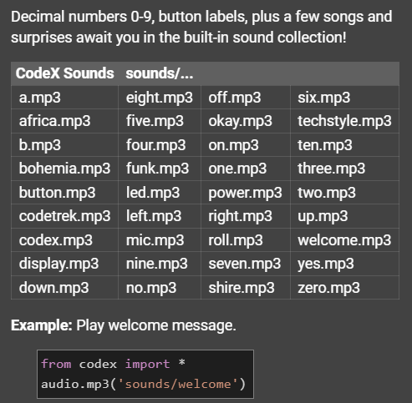

💡 **Teaching tip – Objective 4:**

Students experiment playing different **sounds/songs** on the CodeX, using the pre-loaded audio files. The examples in CodeSpace have the name of the audio file, but it doesn’t include **sounds/** . To play a built-in file, they must include **sounds/** in front of the name. Students can use double quotes (“ “) or single quotes (‘ ‘). Either one works.

Refer them to the 

**NOTE:** Students may want to stop the play of a long song. At this time, that cannot be done, other than restarting the CodeX or clicking STOP for the program execution. Once it starts, it will play through before anything else happens.

💡 **Teaching tip – Objective 6:**

This objective has students put batteries in the CodeX and run their program “unplugged.” If you don’t have batteries, the students can still complete the mission, since the only requirement is to find the BATT switch on the simulator. However, if you have batteries, it is a good experience for the students to try it out here.

💻 **Teaching tip – Extension:**

This mission should take a regular class period with the warm-up and wrap-up. However, if some students finish early, or you have a shorter warm-up and wrap-up, they may have time for an extension. Students can come up with their own idea, or try one of these:

* Create a string variable for the audio file and use it in your code
* Program several buttons to play music
* Before the music plays, add one or more of these:
  + Turn on the color of the pixels
  + Display an image
  + Fill the screen with a color

💻 **Teaching tip – Extension:**

Another possibility for an extension is to let students add their own MP3 audio files to CodeX. Instructions are in the “Adding Audio to CodeX” slides. Try it yourself first before having students do it. There is a lesson later on where students will add their own images to CodeX, so you can wait until then and not miss out on anything.

✅ Assignment is complete and ready to turn in.

**Wrap-Up (5 minutes)**

🧑‍🤝‍🧑 **Discuss** – Use a discussion strategy, like journaling, working at boards, selecting random students, or a form of think-pair-share. This discussion question is also excellent as a warm-up.

🧑‍🤝‍🧑 Discuss real-world applications of digital music. Some examples include:

* Musical gift cards
* Ringtones
* Drum Machines
* Keyboard Synthesizers

✅ **IMPORTANT!!**

Students should clear their CodeX by running their ClearCodeX program.

✅ If this lesson is completed in one class period, the following can be used as a wrap-up. If you are on a block schedule and continuing to the next lesson, a wrap-up isn’t necessary.

Formative Assessment:

* Daily reflection journal
* Completion of assignment
* Music1 program
* Mission 5 Kahoot Review (review topics from previous missions as well as Mission 5)
* Exit ticket on vocabulary
* Group review on vocabulary

**SUCCESS CRITERIA:**

* Create a program that plays an audio file on the CodeX
* Add readability to your program by adding blank lines and comments
* Debug any errors in the code